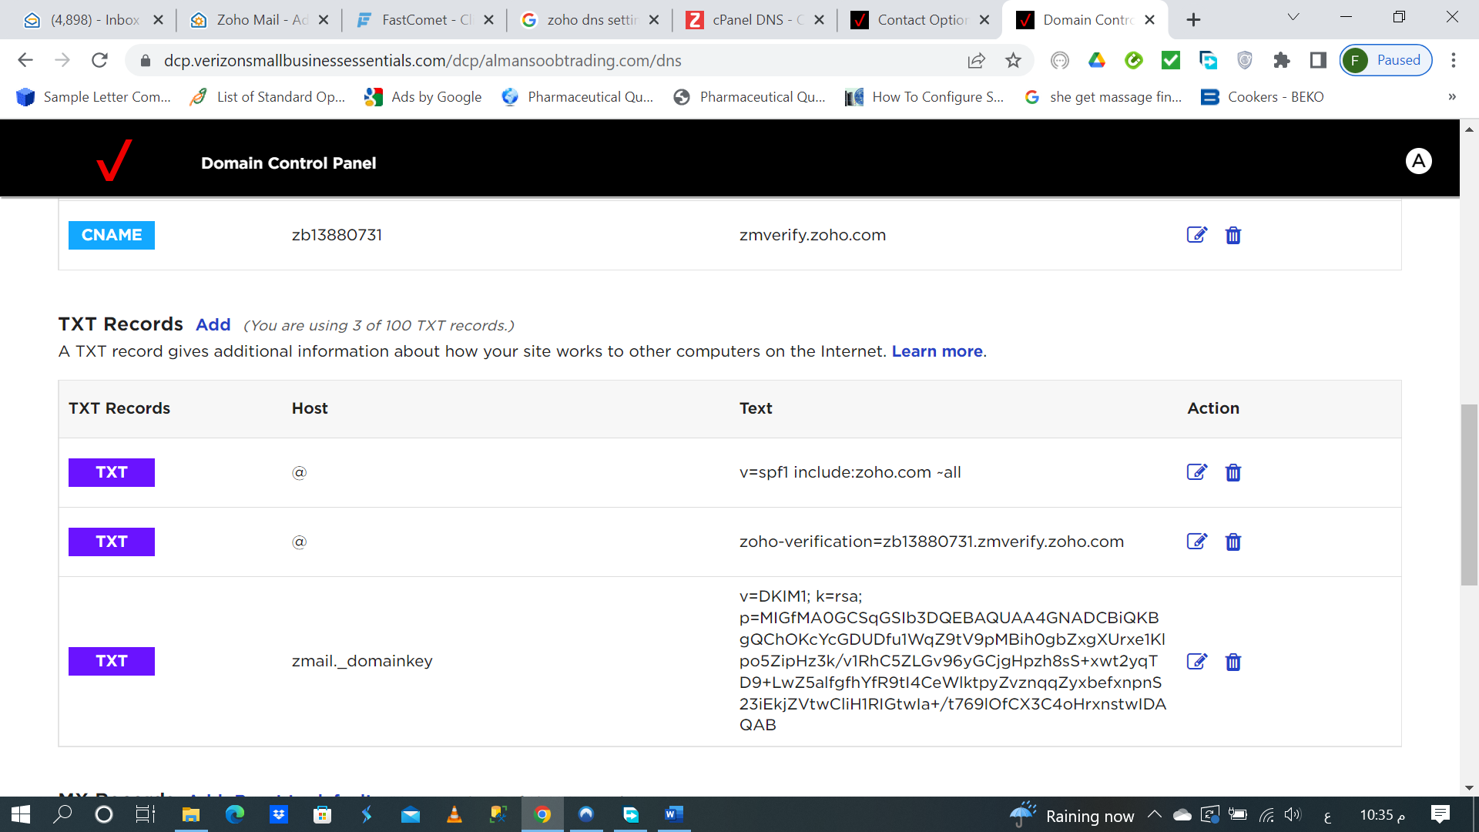

zb13880731 | zmverify.zoho.com

TXT Records | Host | Text | Action
TXT | @ | v=spf1 include:zoho.com ~all
TXT | @ | zoho-verification=zb13880731.zmverify.zoho.com
TXT | zmail._domainkey | TXT RecordsAdd(You are using 3 of 100 TXT records.)  A TXT record gives additional information about how your site works to other computers on the Internet. Learn more.  MX RecordsAddReset to default(You are using 3 of 10 MX records.)
  zb13880731 | zmverify.zoho.com
  TXT Records | Host | Text | Action
  TXT | @ | v=spf1 include:zoho.com ~all
  TXT | @ | zoho-verification=zb13880731.zmverify.zoho.com
  TXT | zmail._domainkey | v=DKIM1; k=rsa; p=MIGfMA0GCSqGSIb3DQEBAQUAA4GNADCBiQKBgQChOKcY  cGDUDfu1WqZ9tV9pMBih0gbZxgXUrxe1Klpo5ZipHz3k/v1RhC5ZLGv96yGCjg  Hpzh8sS+xwt2yqTD9+LwZ5alfgfhYfR9tI4CeWlktpyZvznqqZyxbefxnpnS23iEkjZVtw  CliH1RIGtwIa+/t769lOfCX3C4oHrxnstwIDAQAB
  MX Records | Mail Server Host Name | Priority | Action
  MX | mx.zoho.com | 10
  MX | mx2.zoho.com | 20
  MX | mx3.zoho.com | 50

MX Records | Mail Server Host Name | Priority | Action
MX | mx.zoho.com | 10
MX | mx2.zoho.com | 20
MX | mx3.zoho.com | 50

